**Reference of programming 2 assessment**

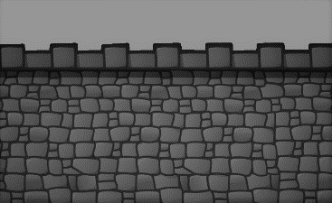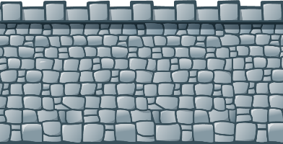

(Cavaill, 2021)

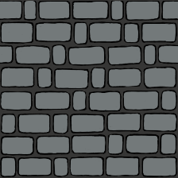

(Aetherna, 2016)

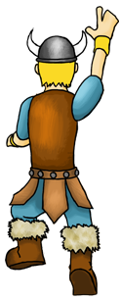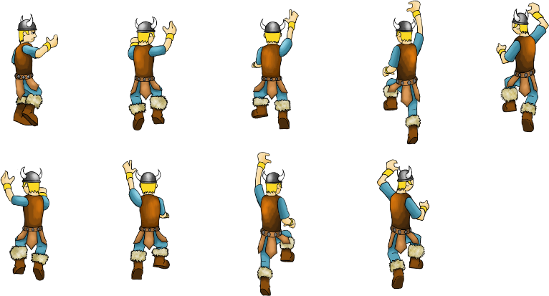

(CLIPARTMAX, 2019)



(Jusselik, 2015)

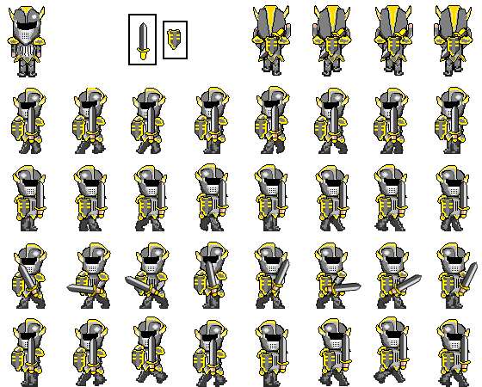

 (thomaswp, 2013)

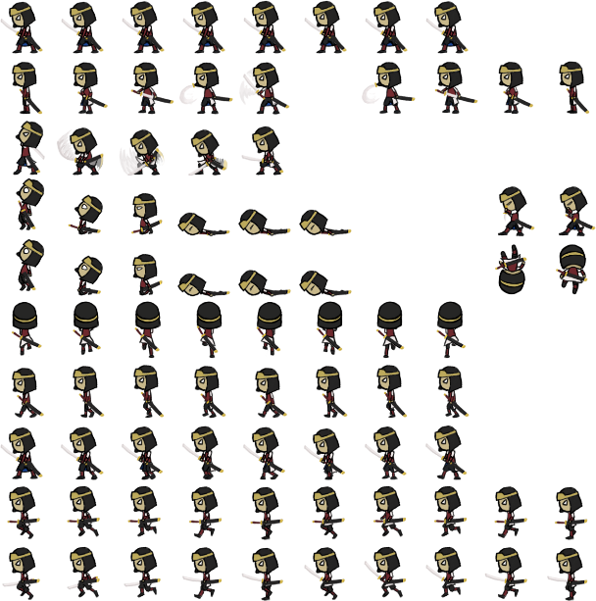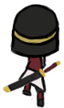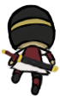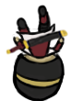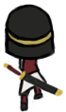

(pngfind, 2019)

# References

Aetherna, 2016. *Stone Brick Wall Background.* [Online]   
Available at: https://opengameart.org/content/stone-brick-wall-background  
[Accessed 16 December 2021].

Cavaill, O., 2021. *PNGITEM.* [Online]   
Available at: https://www.pngitem.com/middle/ioowRmi_stone-wall-clipart-clip-art-stone-wall-hd/  
[Accessed 16 December 2021].

CLIPARTMAX, 2019. *Sprite Sheet Climb Cycle Shaded 72dpi - Sprite Character Climb.* [Online]   
Available at: https://www.clipartmax.com/middle/m2H7H7d3m2G6Z5K9_sprite-sheet-climb-cycle-shaded-72dpi-sprite-character-climb/  
[Accessed 16 December 2021].

Jusselik, J., 2015. *Aesthetic, Overlay, And Png Image-Aesthetic Stars Crown Png, Transparent Png.* [Online]   
Available at: https://www.pngitem.com/middle/ibTboho_aesthetic-overlay-and-png-image-aesthetic-stars-crown/  
[Accessed 20 December 2021].

pngfind, 2019. *pngfind.* [Online]   
Available at: https://www.pngfind.com/mpng/homwiwi_sprite-animation-2d-computer-graphics-line-png-image/  
[Accessed 23 December 2021].

thomaswp, 2013. *Knight.* [Online]   
Available at: https://www.clipartmax.com/middle/m2H7H7d3m2G6Z5K9_sprite-sheet-climb-cycle-shaded-72dpi-sprite-character-climb/  
[Accessed 16 December 2021].